**Information**

|  |  |  |
| --- | --- | --- |
| **CRIM ID** | **Title** | **Workstream** |
| C0609 | C0609 - Additional Fields on Forecasting Screens | Forecasting |

**Revision History**

|  |  |  |  |
| --- | --- | --- | --- |
| **Revision** | **Date** | **By** | **Remarks** |
| 0.1 | 22/03/2021 | Jen Anderson/Ivan Saxelby | Base spec |
| 1.0 |  |  | Updates |
|  |  |  |  |
|  |  |  |  |

# CRIM Narrative

Additional screens are required to be added to Forecasting screens, to enable the user to see at a glance part related attributes, that would otherwise require zooming off to a different screen.

Add Product Family and Product Code fields:

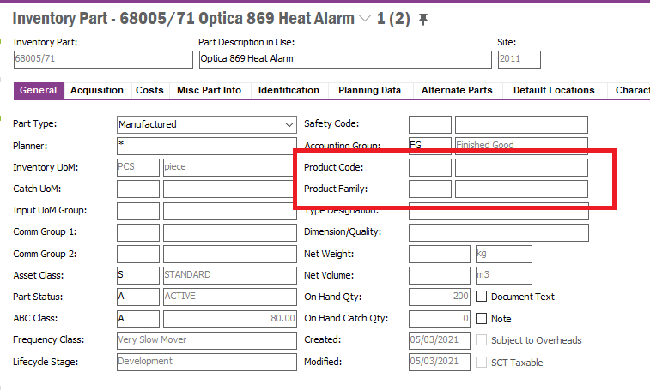

To the following screens:

1. MS Level 1 Parts per MS Set

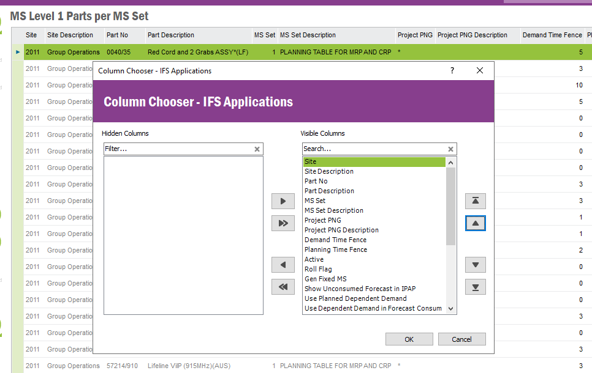

1. MS Level 1 Part

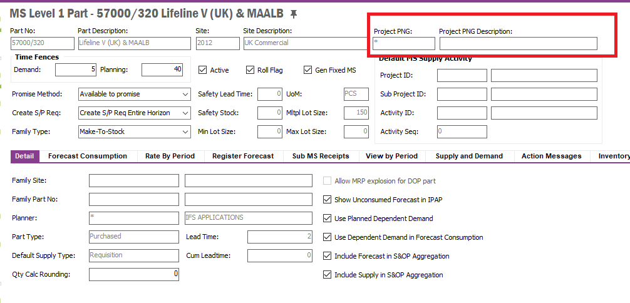

Remove (hide) Project PNG and Project PNGF Description fields and replace Product Family & Product Code.

(3) MS for Multiple Parts screen – add as a Column (Column Chooser)

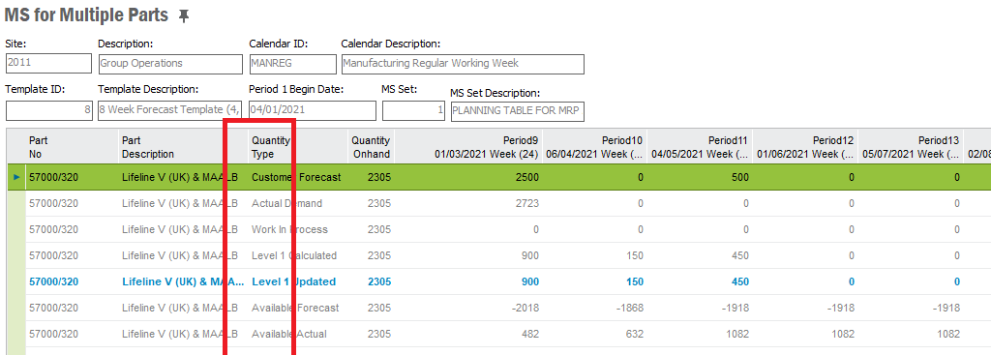

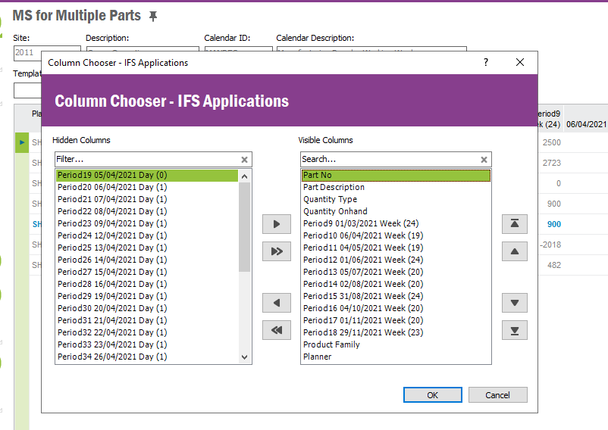

# Technical Proposal

# Technical Solution

## Technical Process

***********************************************

## Report Components

********************************************

## Known Dependencies

*\*\*\*\* Guidance Notes – Remove prior to submission \*\*\*\**

***********************************************

# Deployment Instructions

*\*\*\*\* Guidance Notes – Remove prior to submission \*\*\*\**

***********************************************

# Developer Test Proposal

*\*\*\*\* Guidance Notes – Remove prior to submission \*\*\*\**

* *Tests recommended by the developer to be included in UAT*

*e.g.*

| **Test ID** | **Recommended Test** |
| --- | --- |
| 1 | Test the boundaries of all parameters |
| 2 |  |
| 3 |  |
| 4 |  |
| 5 |  |
| 6 |  |
| 7 |  |

***********************************************

# User Acceptance Tests

***********************************************

# Delivery Notes

Package

**EA_FORECASTING**

Permissions Granted

**IFS_ALL**

Technical Limitations

Technical limitations as follows,

1. It is not possible to add the two custom fields to the “**MS Level 1 Parts per MS Set**” window.  This window is based on the “**LEVEL_1_PART_EXT**” view in which the **OBJKEY is not available**. Therefore, this view does not support any custom fields.

1. Adding the custom fields into the “**MS for Multiple Parts**” screen is also not possible since the view is not a base view. Therefore, this does not support any custom fields too.

Custom Fields

To hide the **Project PNG** and **Project PNG Description** fields in the MS Level 1 Part Window, RMB on the header, Properties, Layout, Untick the two tick boxes of the two fields as follows.

To add the two new custom fields into the layout, RMB on the header, Properties, Layout, tick the two tick boxes of the two fields as follows.

Note – If the two fields are not visible in the Object Properties Dialog Box, make sure the following the Logical Unit is approved, published, and synchronized.

